CpE 476 Mobile Robotics

Romi32U4 Report

By

Bruce Moquete, Nicolas Harris, Elmer Mejia

**Objective**

The task in this report is to control a Romi32U4 robot through the I2C of a Raspberry Pi 3 using a keyboard while logged onto the Rpi3 (Raspberry Pi 3) through SSH utilizing ROS (Robotic Operating System) and the tools provided by ROS such as ROS serial. To shorten this ordeal, this report will utilize an online tutorial that provides the user with the Github repository containing the Arduino code for the Romi and the ROS packages on the Rpi3. This tutorial and Github repository can be found at <http://www.peterklemperer.com/blog/2019/05/02/introducing-romipi-a-ros-package-for-the-pololu-romi/> and <https://github.com/ftPeter/RomiPi> respectively. The following steps will be described in order to achieve the primary task:

**Setting Up the RPi**

* **Start by setting up Ubiquity Robotics on the Rpi3 by downloading the image file onto an SD card and installing the OS on the Rpi.** <https://downloads.ubiquityrobotics.com/pi.html> **(Note: follow the instructions and use the tools suggested on the page for optimal installation)**
* **Next, log into the Rpi and set up your WiFI or use the access point provided by the OS to connect your laptop or desktop to the Rpi. It is however recommended that you connect through SSH and have your Rpi connect to your home WiFi.**
* **Enable SSH, I2C, and install tightvncserver and Terminator terminal onto your Pi. The first two are done through the terminal using the command: sudo raspi-config, selecting Interfacing Options and enabling both features. After which, install tightvnc through the comman: sudo apt-get install tightvncserver. After setting up your vnc install the Terminator by typing: sudo apt-get install terminator on your command line. The reason this is done is because the task will require the use of 2 terminals.**

**Setting Up the Romi32U4**

* **To set up the Romi32U4, head to the Github repository provided above. Download the repository and open the Romi-RPi-I2CSlave folder and open the executable using the Arduino IDE. Once all of the files are opened up in the new sketch in your Arduino IDE verify it. If some libraries are missing simply go to the repository you downloaded and in the Arduino folder copy all of the libraries into your Arduino-IDE’s library folder.**
* **Now before uploading onto the board, make sure the Servo.h header file is uncommented as this will hinder the program when it runs on your Rpi.**

**Setting Up ROS**

* **On your Rpi, go into your ROS workspace or create a new one. Go into your src folder within the workspace and clone the repository from above into the src folder. Before performing the catkin_make command, head into the newly cloned repository in your catkin workspace (RomiPi) and search for every instance of turtlebot3 used in the package. The reason for this is because your RPi does not have gazebo installed and because you are using ROS kinetic, turtlebot3 is for Melodic not Kinetic so it will not work. After that, perform the catkin_make command. If all turtlebot3 instance have not been deleted or commented out the command will fail.**
* **The next step involves connecting to your Rpi through VNC and opening up two terminals which should look like this:** 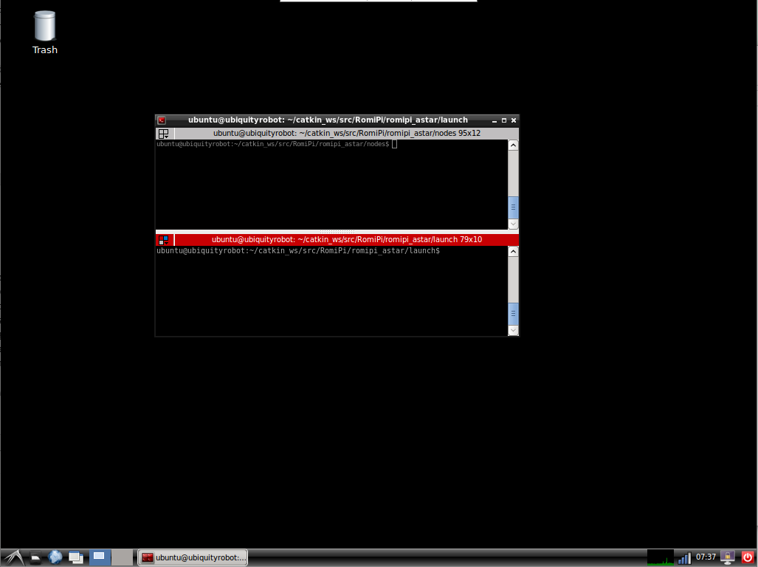
* **Next, in one of the terminals run the command roslaunch romipi_astar romipi_astar_node.py or romipi_astar_node.launch (Note: The online tutorial will say to use romipi_astar_node.launch for the second command but that will not work) If any errors appear they are simply syntax errors in python (Indentation problems, missing parenthesis, etc)**
* **Next, in the other terminal use the command roslaunch romipi_teleop romipi_teleop_key.launch to start the teleop program. As with the astar node launch, some errors may appear which are syntax based.**
* **The final step is to reset your Arduino board (even if both ROS packages are running ) and you should now be able to control your Romi.**

**Demonstrations**

<https://youtu.be/Xs33tJNUkMs> (ROS Terminals)

<https://youtu.be/Oyzo4Wuzom8> (Romi32U4 Robot)